# So Make It Draft Health & Safety Policy

Contents

So Make It Draft Health & Safety Policy 1

Health & Policy Summary 2

Health & Safety Management 2

Under 18s 2

CRB Checks 2

First aiders 2

Disclaimers 2

Insurance 2

Electrical Safety 2

PAT Testing 2

Fire Safety 2

Fire Extinguishers 2

Fire Alarms 2

COSHH 3

So Make It is a not-for-profit group providing tools, space, equipment and skills to allow people to build, create, make and design things. It has a small group of directors, referred to as "trustees" which are responsible for maintaining the legal structure of the business but the group is run by its members.

So Make It conducts most of its activities at its rented workshop here:

Unit K6,

Liners Industrial Estate,

Southampton,

SO15 3FQ

There are regular open nights for members and guests to come and use the space while trusted members are allowed keys so they can come and go as they please. There are also occasional workshops normally on the premises and arranged by members but there are occasions where members of So Make It might run these workshops at external events.

## Health & Policy Summary

So Make It's general health & safety policy and number one rule is a humorously shortened to "Do not be on fire!" which implies that users of the space should take care of their well being and those around them.

## Health & Safety Management

While responsibility for checking health and safety falls upon the membership there is an appointed person(s) in charge of Heath and Safety management at the space.

## Under 18s

Under 18s may enter the space if accompanied by a parent or legal guardian who will responsible for their actions and safety.

## CRB Checks

No members of So Make It are required to or are logged as having CRB checks as our under 18s policy states under 18s must be accompanied by a parent or guardian.

## First aiders

There are no first aiders or appointed persons because it cannot be guaranteed that one will be available during opening hours.

## Disclaimers

We do not make members or visitors sign waivers to absolve health and safety responsibility as they are unenforceable in the UK under the unfair terms in contracts regulations 1999:

http://www.legislation.gov.uk/uksi/1999/2083/made

We may however make members or visitors sign to say they are competent at using a particular piece of equipment to ensure that dangerous equipment is used safely.

## Insurance

There is public and employer liability insurance in place which is managed by the treasurer.

## Electrical Safety

### PAT Testing

It is not feasible to PAT test equipment within the workshop nor is it a legal requirement.

## Fire Safety

### Fire Extinguishers

Three fire extinguishers are located by the main entrance underneath the first aid kits. Co2, Dry Power and Water and are labelled

### Fire Alarms

There are smoke alarms in each of the upstairs offices and in the downstairs workshop. These may be temporarily disabled during activity where smoke may be generated (e.g. soldering workshops) but must be reactivated upon the activity being over. The person who deactivates the alarm is responsible for making sure it is active again.

Batteries are checked

There is also a heat activated alarm

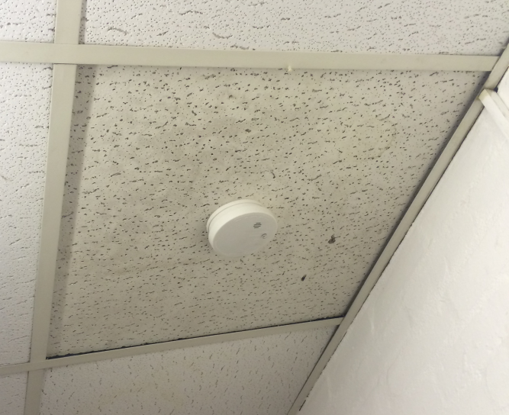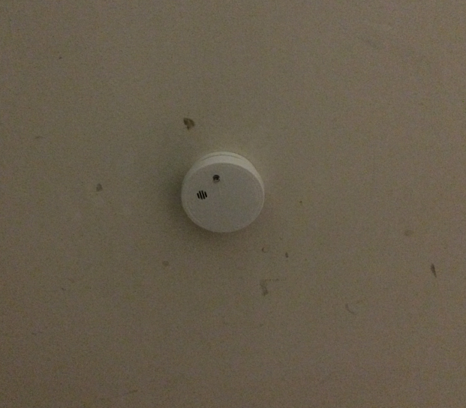

*Upstairs Office 1 Smoke Alarm (Left) and Downstairs Workshop Smoke Alarm (right)*

## COSHH

The Control Of Substances Hazardous to Health (COSHH) regulations are an important part of the makerspace health and safety. It is vital that all members understand our basic COSHH policy to protect themselves and any visitors to the space.

In summary the policy is very simple; all substances that might be hazardous are kept in a lockable storage cupboard along with full safety datasheets in our COSHH folder. It is up to all members to make sure this information is up to date and that methods of control are available at the space for any of the substances. For example: Flammable liquids such as petrol should have suitable fire fighting equipment available near where they may be used such as a fire blanket for emergencies or a bucket of sand for accidental spillage.

Our cabinet is currently the filing cabinet in the downstairs workshop opposite the main entrance and a list of its contents can be found electronically here:

**https://wiki.somakeit.org.uk/wiki/Chemicals**